SENG3500 Laboratory 2 Report – Simulation Experiment II

# Introduction

The purpose of the simulations in this report is to analyse the queues, traffic patterns and delays of the M/D/1, M/M/1 and M/M/1/K systems under a variety of different parameters. The results of the simulations will be analysed to determine which systems are appropriate for each circumstance.  
Using the provided FIFO model, a number of simulations will be run to test:

1. The mean packet delay, mean queue delay and mean queue length of the 3 queue systems given different loads,
2. M/M/1 packet delay for 3 different random seed values,
3. M/M/1/10 packet loss for different load values,
4. Queue size vs. packet loss for different load values.

# Simulation Model

The simulation uses a basic first-in-first-out (FIFO) queuing model. As a FIFO model, packets are processed in the order that they arrive. All iterations use a single input for arrivals, a single output for services and a delay box to simulate a queue. The delay box has a function for “dropping” packets, but this only applies to queues of finite length.

The M/D/1 model uses an exponential packet inter-arrival time and a fixed service time, simulated by keeping packet length as a fixed variable.   
The M/M/1 model uses an exponential packet inter-arrival time and an exponential service time, simulated by having exponential packet length. Both of these models have a queue of infinite length.  
The M/M/1/10 model has a queue with a packet limit of 10, but is otherwise identical to the M/M/1 model. The model will dump packets when the queue is maxed, logging these details.

To ensure that results remain consistent across all tests, a random seed value can be set. The model will always output the same results with a specific seed. All simulations use a seed value of “100” unless otherwise specified.

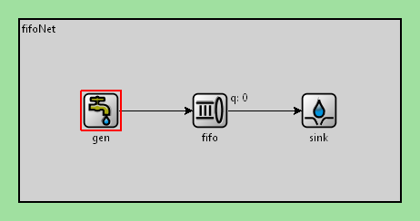

Figure . FIFO queue, with a packet generator (gen), packet queue (fifo) and packet destination (sink).

# Results

|  |  |  |  |  |  |  |
| --- | --- | --- | --- | --- | --- | --- |
| **Traffic load** | 0.1 | 0.3 | 0.5 | 0.7 | 0.9 | 1 |
| **Mean packet delay** | 0.1047 | 0.121 | 0.1575 | 0.2361 | 0.9676 | 8.6367 |
| **Mean queue length** | 0.4955 | 0.7073 | 1.1064 | 1.8739 | 9.2959 | 88.2663 |
| **Mean queue delay** | 0.0047 | 0.021 | 0.0575 | 0.1361 | 0.8675 | 8.5383 |

Table . M/D/1, seed = 100

|  |  |  |  |  |  |  |
| --- | --- | --- | --- | --- | --- | --- |
| **Traffic load** | 0.1 | 0.3 | 0.5 | 0.7 | 0.9 | 1 |
| **Mean packet delay** | 0.1096 | 0.1395 | 0.2002 | 0.3359 | 0.9386 | 6.5609 |
| **Mean queue length** | 0.5704 | 0.946 | 1.4906 | 2.8725 | 8.8615 | 68.3581 |
| **Mean queue delay** | 0.0092 | 0.043 | 0.1025 | 0.2365 | 0.8395 | 6.4639 |

Table . M/M/1, seed = 100

|  |  |  |  |  |  |  |
| --- | --- | --- | --- | --- | --- | --- |
| **Traffic load** | 0.1 | 0.3 | 0.5 | 0.7 | 0.9 | 1 |
| **Mean packet delay** | 0.1096 | 0.1395 | 0.2002 | 0.3128 | 0.5164 | 0.6241 |
| **Mean queue length** | 0.5704 | 0.946 | 1.4906 | 2.5422 | 4.3411 | 5.2152 |
| **Mean queue delay** | 0.0092 | 0.043 | 0.1025 | 0.2132 | 0.4169 | 0.5242 |
| **Packet loss** | 0 | 0 | 0 | 36 | 270 | 304.5 |

Table . M/M/1/10, seed = 100

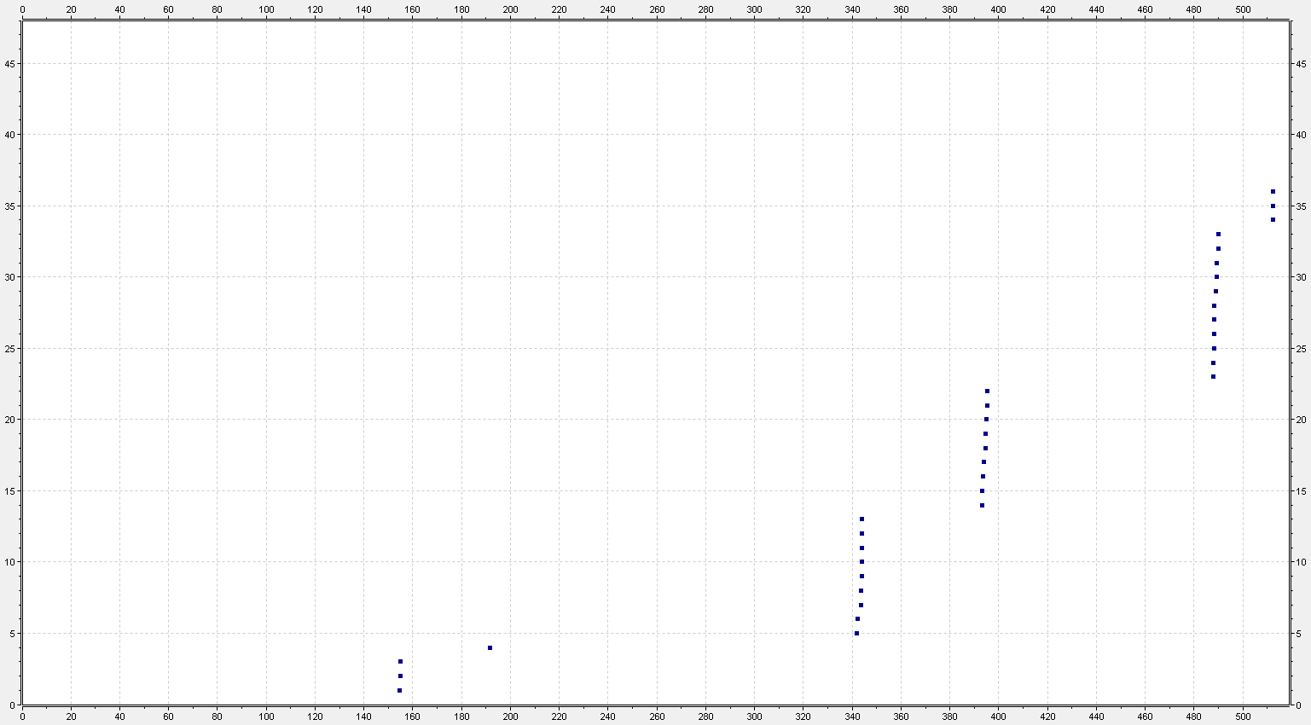

Figure . M/M/1/10 packet loss, p = 0.7, seed = 100

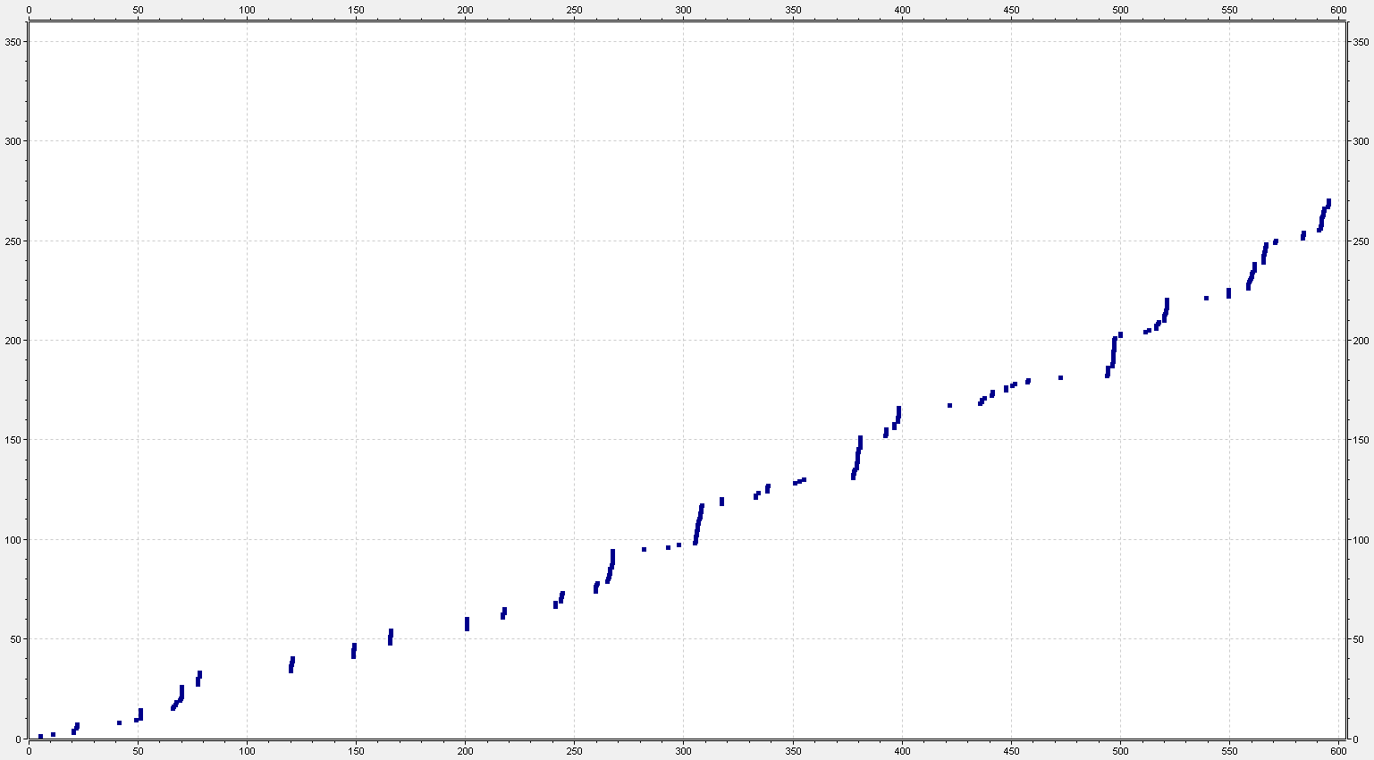

Figure . M/M/1/10 packet loss, p = 0.6, seed = 100

|  |  |  |  |  |  |  |  |  |  |  |  |  |  |  |
| --- | --- | --- | --- | --- | --- | --- | --- | --- | --- | --- | --- | --- | --- | --- |
| **Queue size** | 10 | 15 | 20 | 25 | 30 | 35 | 40 | 45 | 50 | 55 | 60 | 65 | 70 | 75 |
| **Packet loss** | 443 | 277 | 186 | 141 | 113 | 88 | 65 | 53 | 47 | 34 | 29 | 19 | 16 | 11 |

Table 4. M/M/1/n, p = 0.95

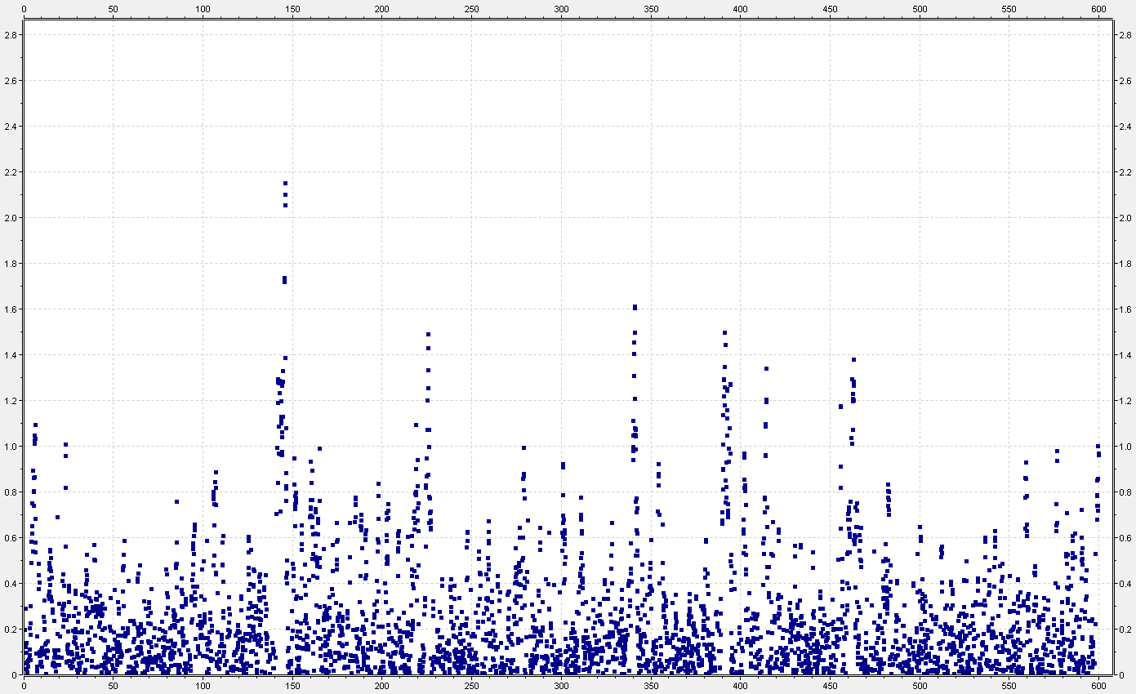

Figure . M/M/1, p = 0.6, seed = 38

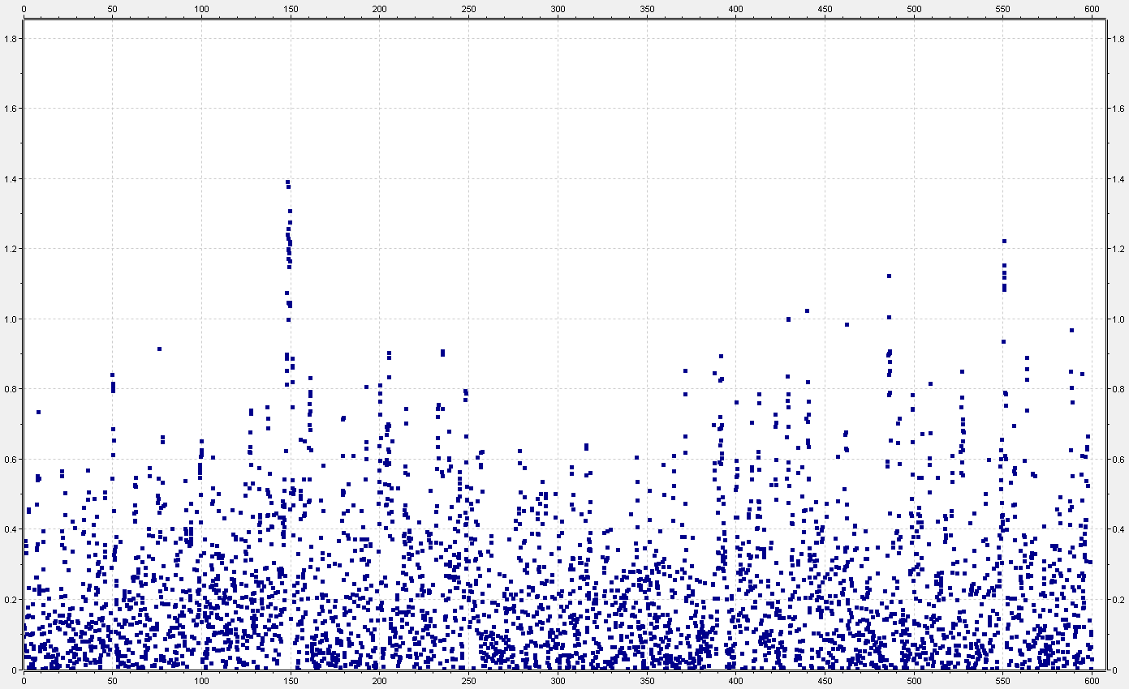

Figure . M/M/1, p = 0.6, seed = 94

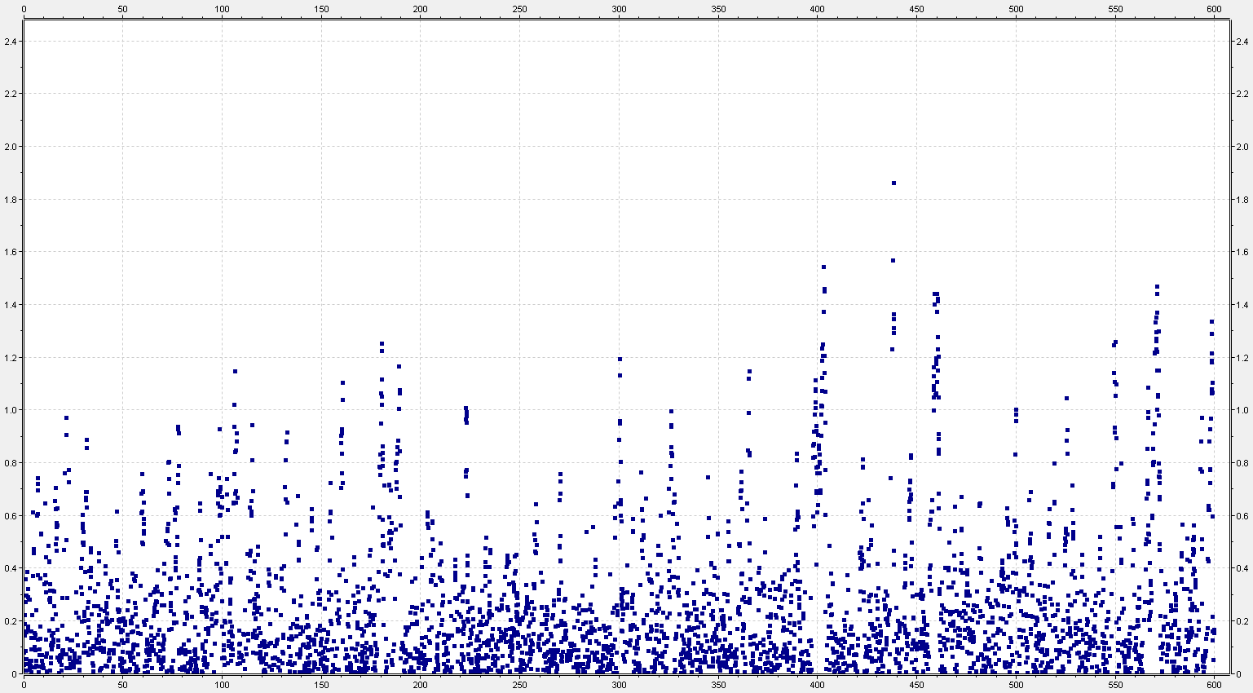

Figure . M/M/1, p = 0.6, seed = 100

# Analysis

The M/D/1 model shows the best results when the traffic load is smaller, showing lower queue lengths and delays. As the traffic load increases and the queue becomes longer, it begins to underperform.  
The M/M/1 model starts out less efficient than the M/D/1 model. While delays become much more significant as the queue length increases, they are notably smaller than the previous model  
The M/M/1/10 model starts out as efficient as the M/M/1 model. However, as the queue reaches the maximum and packets are dropped, delays only increase to about 10% compared to the previous model.

# Knowledge

1. *Calculate the theoretical packet delay values for M/M/1/10 and M/M/1 models, using ρ = 0.5 and 0.7. Use the same service rate as that in the simulation model.*

|  |  |
| --- | --- |
| ρ = 0.5 | ρ = 0.7 |
| μ = 10000/1000 = 10 | μ = 10000/1000 = 10 |
| E[T] = [0.5 / (1-0.5)] * (1/10) + (1/10)  = **0.2** | E[T] = [0.7 / (1-0.7)] * (1/10) + (1/10)  = **0.333…** |

1. *Compare the theoretical values calculated in Question 1 with the simulation results obtained. Explain why these results are the same or different?*

|  |  |  |
| --- | --- | --- |
|  | **Theoretical** | **Simulated** |
| **ρ = 0.5** | 0.2 | 0.2002 |
| **ρ = 0.7** | 0.333… | 0.3359 |

The results are similar, however the simulated figures are slightly higher.

This discrepancy can be explained by factoring in randomness. The theoretical equation implies a “perfect” environment – no unexpected interruptions and tightly controlled variables. By contrast, the simulation might account for unexpected interruptions or differently-sized delays.

1. *Compare the packet delay and packet loss values obtained using the M/M/1 and M/D/1 models. Explain the differences you can observe by examining the load vs packet delay and load vs packet loss simulations.*

As the load increased, the packet delay values increased exponentially. A major spike in the values could be observed when the load value reached 0.7. It is at this point where the queue became particularly bloated. Both models showed high growth in this area, although the packet delay growth was slightly less in the M/M/1 model.

Observing the M/M/1/10 model, we can see that at this time, the number of lost packets also increased sharply. From this it can be confirmed that the load was not sufficient to overly tax the queue, and thus packet delays remained relatively small.

1. *Explain the effect of using a random number for different seed values in the simulation model. Do you see any change of the packet delay distribution? Explain any differences you have observed using the different seed values.*

The seed produces a stream of random numbers. Owing to the difficulty of producing a truly random number in the purely mathematical environment of a computer, that seed is processed with a fixed algorithm which therefore always produces the same result. This is called a pseudo-random number, as it only seems to be random.

The benefit to this is that a seed will always produce the same “random” stream of values, allowing the user to get consistent results. These values are multiplied with the fixed delay and process times and the final seemingly-random value is what is used.

Although the average packet delay remains relatively stable, the packet delay distribution is completely different across all seed values. These differences can be explained with simple probability – though the distribution is random, given a range of random variables, over time they will average out to the midpoint of the range.

1. *Explain the effect(s) of buffer size selection on the QoS value of the outgoing traffic of a network switch.*

A smaller buffer size will shorten packet/queue delays but will result in more lost packets. This means that networks will be less congested and faster moving, but the quality/integrity of data will be diminished. If not excessive, this can be acceptable for video conferencing or streaming services.

A larger buffer size will lengthen delays but it is more likely that data will be preserved. This is important for things like financial services, where precision is more important than speed.

1. *Consider a real communication network where you don’t have control over the traffic arrival process. What changes can you make within a packet switched node to reduce the probability of packet losses and high packet delay?*

The best way of helping this issue is by improving the bandwidth. As the rate of bps is increased, packets are processed more quickly and thus spend less time waiting in the queue. This will reduce packet and queue delay, and reduce or prevent packets from being dropped in networks with smaller queues.